





**Reinforcement learning** (RL) is a machine learning (ML) technique that trains software to make decisions to achieve the most optimal results. It mimics the trial-and-error learning process that humans use to achieve their goals.

Group of actions are more important rather than single action. Corresponding to a good action, a reward will be given.

Machine learning application examples







# Mean Median Mode

<https://www.youtube.com/watch?v=keLk7odKCsE>



Mean is same as average of all the numbers. 32 is an outlier. It affects the mean a lot.

The median is the middle value of SORTED data.



If there are odd values, then the position of a median number = (7+1)/2 = 4 .

If there are even values (2,3,4,5,8,9,32,34), then median number = (5+8)/2 = 6



Mode is the number that occurs the most frequently. There is no mode, if every value occurs only once.

# Variance and Standard Deviation

<https://www.youtube.com/watch?v=D9xfxOzOwrQ>



9 is the average of all numbers.

Then do the calculation as shown for Variance. xi is a number and x-bar is an average number.

Standard Deviation is a square root of Variance. Standard Deviation is a number that shows how the numbers are deviating from the mean (avg) value.

Standard Deviation will be 2 (square root of variance).



Prepare a bell curve like this. 9 is the average and std deviation is 2. All the numbers(observations) are equally distributed in between these deviations. It means that these observations are equally distributed which is good.



In this case, avg is 9. Std Deviation is 9.6.



Wherever there are crosses, you will see that those slots are empty. There are no observations that can fall in these slots. So, numbers are not equally distributed. This is not good.

# Features (Variables) selection technique

<https://www.youtube.com/watch?v=vZDDmULsCUU>

# Introduction to Machine Learning

## Supervised, Unsupervised, Reinforcement Learning



In **supervised learning**, you train a model with given input and output variables. Based on this trained model, you can predict the output of future input data.

Classification means the output can be true or false or just two values.

Regression means output can be anything, not true and false.

In **unsupervised learning**, there is no output variable. You are actually not looking for specific output. You rather want to discover the pattern of data.

Clustering, you are dividing input data into groups. E.g. various types of customers are visiting your shop. Students can be one category, professionals can be another category and so on.

In Association, you need to find frequent co-occurrence of items in the data you are given. Whenever A comes to my shop, B also comes to my shop.

In **Reinforcement learning**, you are learning to control the behavior of the system.

## Performance measures



In Classification and Regression, if desired output is predicted by the model, then we call that there is no error.

In Clustering, if the groups are not so cohesive and they are scattered, then we can say that it’s a weak clustering.

In Association, we will look at later on.

In Reinforcement learning, you need to control the system. So, there is an associated cost to control the system.

## Challenges



<https://www.youtube.com/watch?v=HLqH58OgCMc>



<https://www.youtube.com/watch?v=4dwsSz_fNSQ>



## Noisy Data?

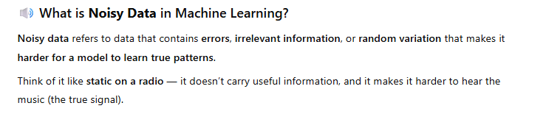

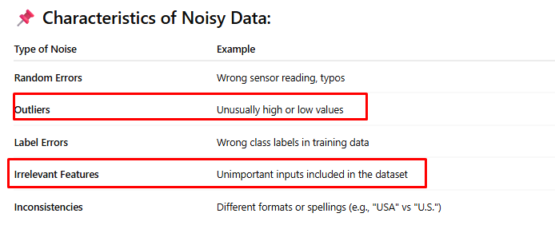

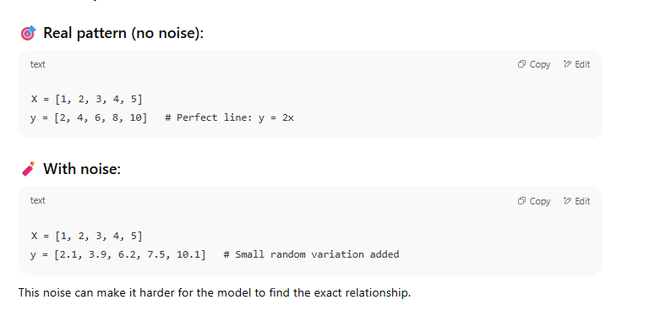

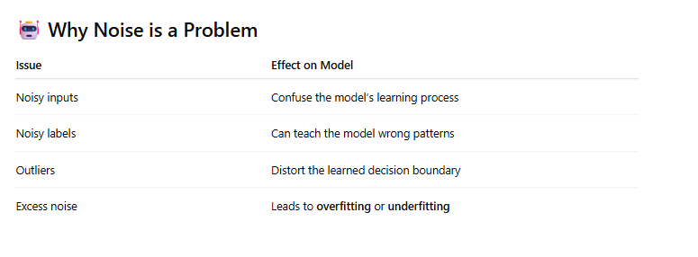

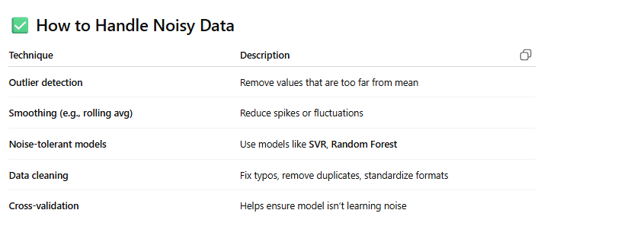

## Underfitting and Overfitting Data

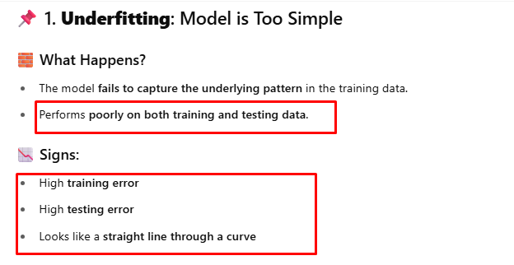

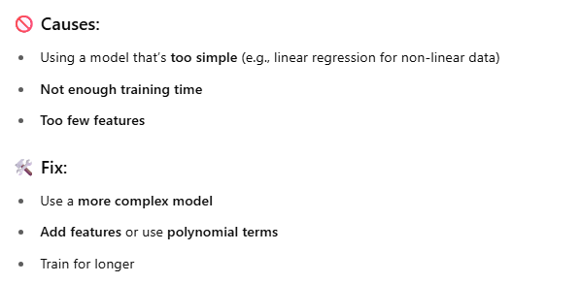

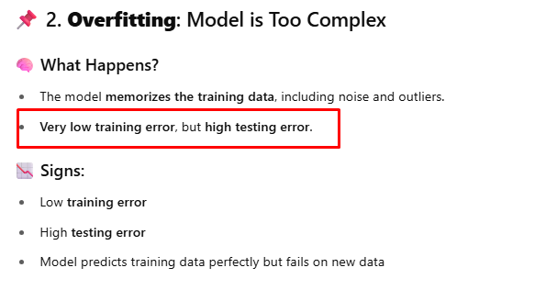

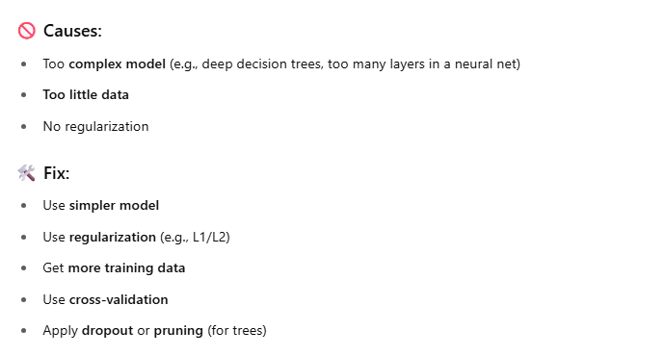

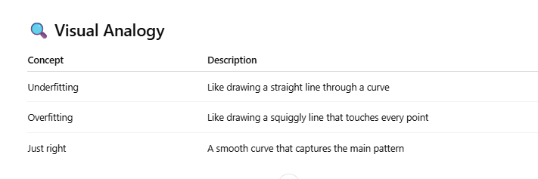

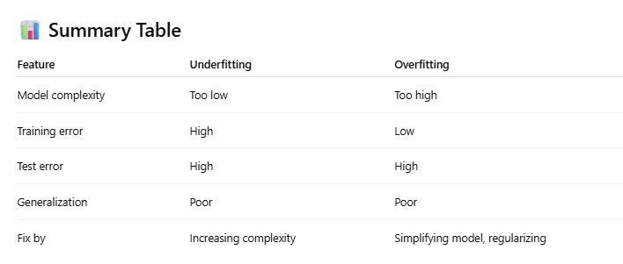

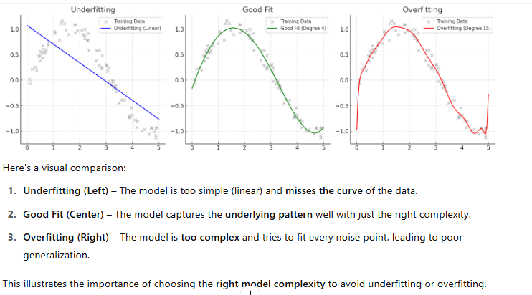

# Supervised Learning

## Linear vs Non-Linear Data















### Data with one input variable(regressor/feature)

To determine whether your data is **linear or non-linear**, follow these step-by-step techniques using both **visual** and **quantitative** methods:

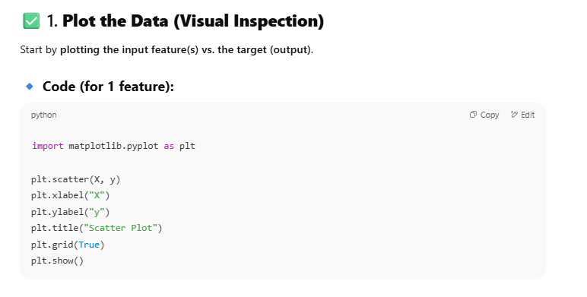

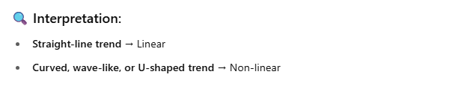

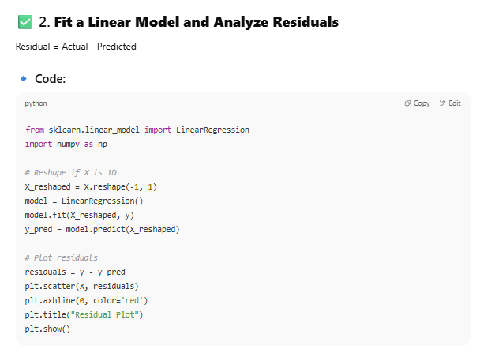

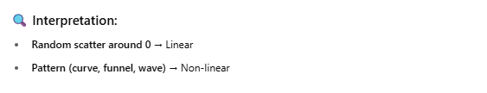

from sklearn.linear_model import LinearRegression  
import numpy as np  
import matplotlib.pyplot as plt  
  
# Study hours (independent variable)  
X = np.array([[1], [2], [3], [4], [5], [6], [7], [8], [9], [10]])  
# Corresponding scores (dependent variable)  
y = np.array([35, 45, 50, 55, 60, 65, 70, 75, 85, 95])  
  
# Reshape if X is 1D  
X_reshaped = X.reshape(-1, 1)  
model = LinearRegression()  
model.fit(X_reshaped, y)  
y_pred = model.predict(X_reshaped)  
  
# Plot residuals  
residuals = y - y_pred  
plt.scatter(X, residuals)  
plt.axhline(0, color='red')  
plt.title("Residual Plot")  
plt.show()

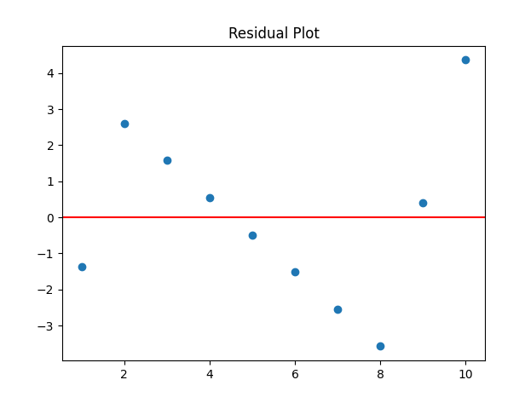

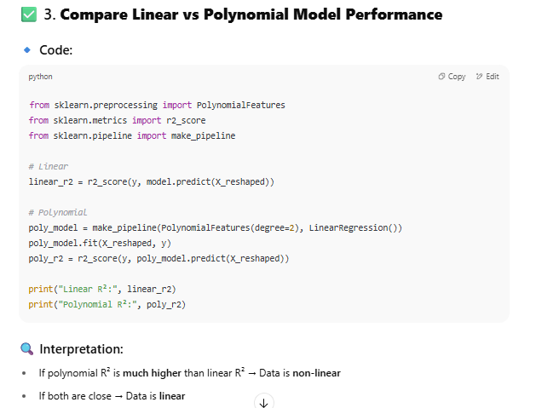

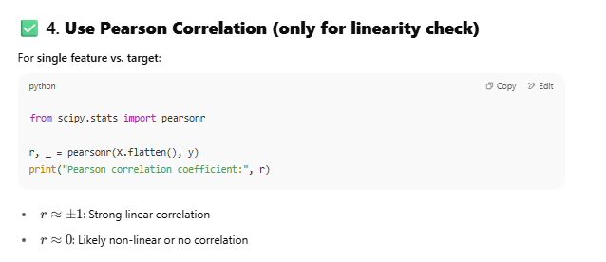

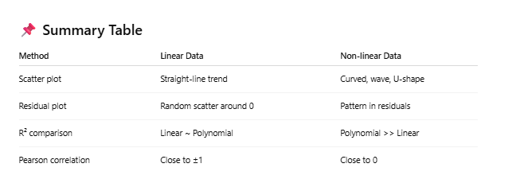

### Data with Multiple input variables(regressors/features)

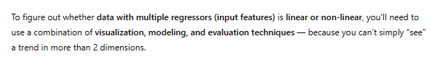

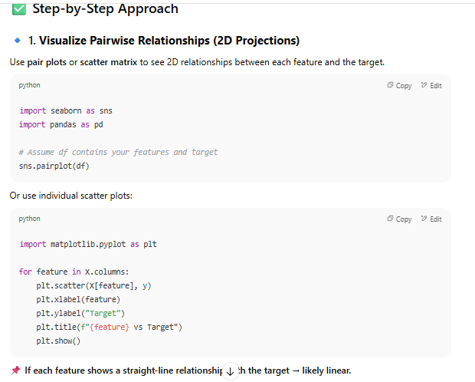

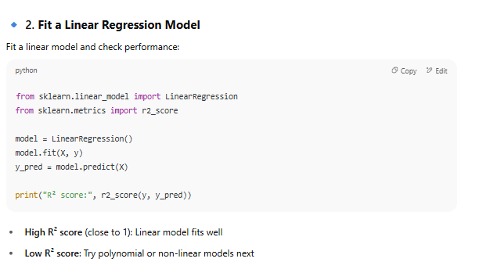

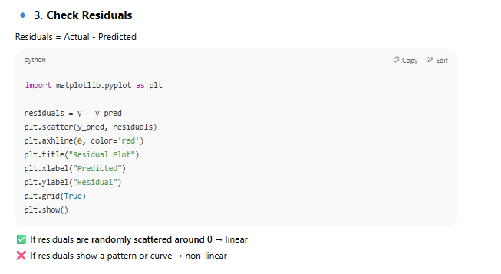

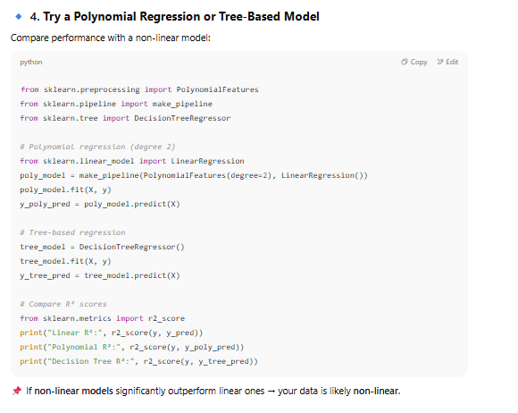

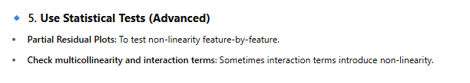

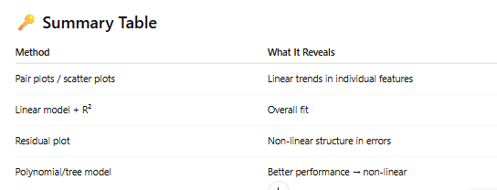

## Classification vs Regression

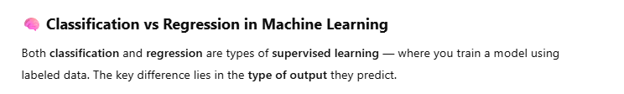

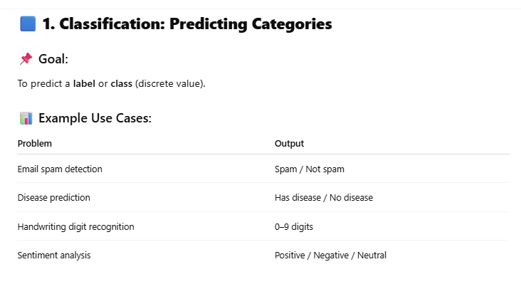

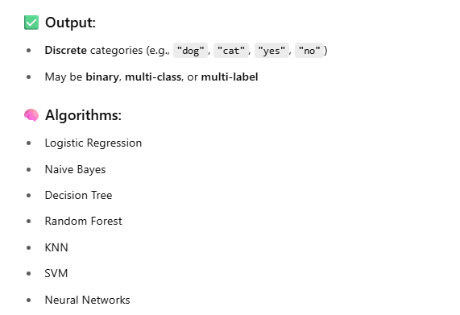

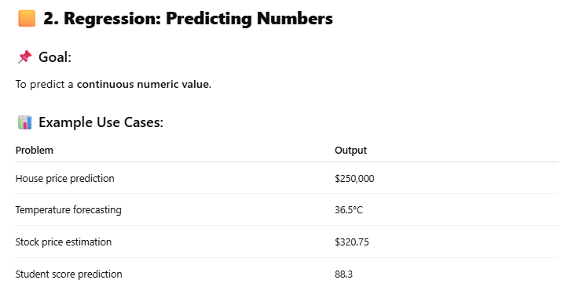

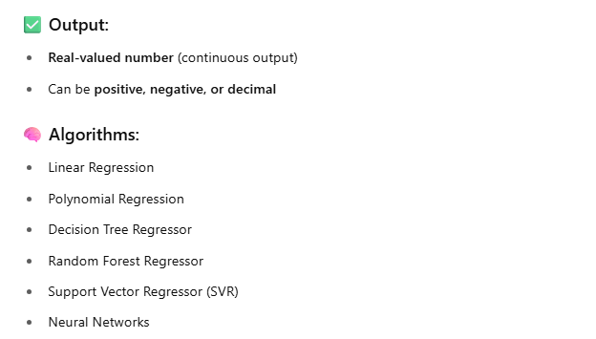

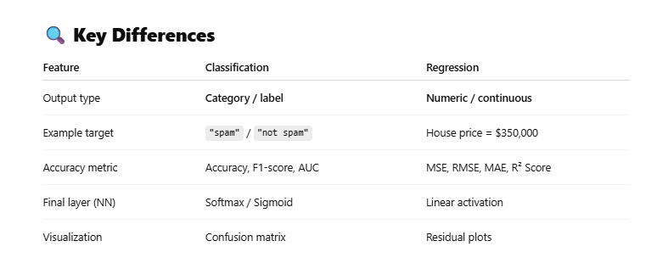

## Interpretability

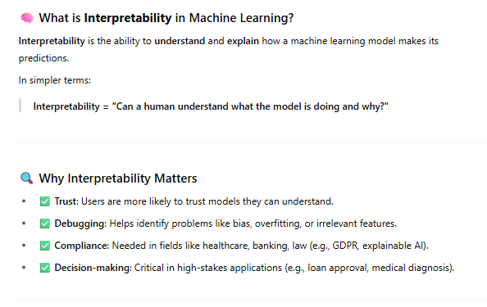

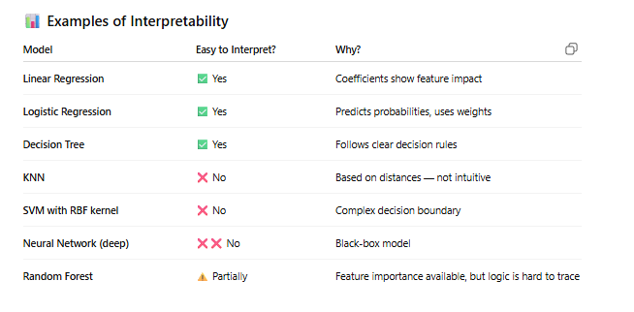

## Classification, one of the Supervised Learning Process

### Possible Classifiers



Let’s say, you are given Income and Age of the customers. From these data points, you have to predict whether the customer will buy the computer or not.



Possible Classification could be everything on left of the line determines the customers that would not buy the computer and everything on right of the line determines the customers that would buy the computer.

In this case, the function would look as follows:

If the income of the person is less than some value, then the person will not buy the computer. If the income of the person is greater than some value, then the person will buy the computer.

In this function, we have considered only Income (not age). With this rule, we can say that we are almost right, but there are some customers whose income is more would still not buy a computer( there are some red dots on right side of the line). We can do slightly better.



To make the prediction slightly better, we need to consider age also. If the customer is older, he needs higher income to buy a computer.

If the customer is younger, he would buy a computer even if his income is little lower.

But if the customer is older, he would buy a computer only if his income is high.

So, by considering age, you get much better predictions.

Can we do better?



You get much better performance by having a costlier classifier.

In the first classifier, I just needed an interceptor line.

In the second classifier, I needed interceptor and a slope.

In the third classifier, I need interceptor, slope and a third parameter in order to find the quadratic.

Can we do better than this?



Just to get one point correct, we need much complex function. You need many parameters to get this kind of classification.

If you see, that particular red point is quite surrounded by a sea of blue. So, there can be a possibility of glitch there. It is possible that that customer might have purchased a computer and we didn’t record it properly or customer comes to the shop for buying a computer, but gets a phone call and leaves the shop immediately. There are higher probability that this red dot is a noise. It is more appropriate to consider previous classifier diagram.

### Inductive Bias



**Inductive Biases** – we made an assumption that everything to the left of the line are the customers who will not buy the computers and everything on the right hand side of the line are the customers who will buy the computers. These kind of assumptions are called inductive biases.

There are two types of Inductive biases.

**Language bias** – whether I am going to draw a straight line or curve etc. decision is called a language bias.

**Search bias** – how in what order am I going to examine all these possible lines.

### The Process



Here, Xs are input variable and Y is an output variable.

Training data of Xs (income and age) and Y(does not buy computer/buys computer) are provided.

Xs are varying too much. 30k to 80k and 25 to 45. This can lead to some numerical instability. So, let’s normalize Xs, so that they form proper range. So, I tried to normalize these X values between 0 and 1. Likewise, I converted Y also in numeric values. **Machine Learning algorithms work only on numeric values.**





Training Algorithm creates a Classifier. Classifier means that line on income-age chart. At this point, we don’t know whether this classifier is good or bad. We need some mechanism to evaluate this.

Using Test data, we can validate the state of Classifier.



If we are happy, we can keep that training algorithm. If we are not happy, then we have to think of changing some parameter values and try to redo the training algorithm. This is actually a very general process and we will see that many algorithms that we will see in future follow the same process.

Inside Training model



Agent creates a output Y thinking it’s a correct output. We will compare it with expected output (target). If there is an error, we will twick the input parameters, so that agent creates the right output from the next time.

Most of the classification and regression algorithms will operate in this way only.

### Applications



### Mathematical formula

<https://www.youtube.com/watch?v=r8OjlgWpAI0>



Sigmoid formula is used for logistic regression



Y is an output variable, x is an input variable. If y’s value is above 0.5, then you can round it to 1 and say that student will pass. If y’s value is below 0.5, then it is closer to 0. Then you can say that student will fail.

Sigmoid formula gives the result always between 0 and 1.

a0 is an intercept. If value of x is 0, then where does y intercept

a1 is a coefficient. It means how much Y changes for a unit change in X.

In training data, you are given both X and Y. You have to find out the values of a0 and a1. Then found values can be used to predict Y for future X.





Linear Regression video will show how to find out a0 and a1. Let’s say a0=-1.5 and a1=0.6. If X=5, then Y will be 0.818, which is closer to 1. It means if a student studies for 5 hours, there are 81% chances for him to pass the exam.

## Regression, Another Supervised Learning Process

### The Process



Regression process is used when expected output is more of a continuous value (not classification).

In this example, input is the Time of Day and output is the temperature measured at particular point in time.

Blue points are the inputs and red points are the output that you are expected to predict. Points to left being Day and points to right being night.

Let’s try to choose the simple solution.



There are certain points at which we are making large errors. To fix that, we could try to do something more fancy



But you can see that while Day time temperatures seem to be fine, night times seem to be doing something really off.

You can do something more fancy to get everything right.



We talked a similar case in Classification and this probably could not be the right solution. This kind of solution where we try to make the solution predict the noise in the training data correctly are known as **over-fitting** solutions. One of the thing that we look to avoid in machine learning is to over-fit to the training data.

You are better off fitting the straight line (Linear Regression).



In linear regression, your aim is to find a line with the least prediction error. You take the square of the errors that your prediction is making and you try to minimize the sum of the squares of the errors.

Why do we take squares?

Because the errors could be both positive and negative and we want to make sure that you are minimizing the error regardless of the sign of the error.



Linear regression is not that simple as it seems like.

When we try to fit a straight line with x1 and x2, I will probably end up with something like a1x1 + a2x2

### Applications



### Mathematical Formula

<https://www.youtube.com/watch?v=zUQr6HAAKp4&t=38s>





You need to find out the value of m and b based on Training data X and Y. X is the input variable and Y is the output variable.







m = 1.5. It means if I change X’s value by 1 unit, Y will change by 1.5 units.



b = Y – m * X

b = -2. It means that if value of X=0, then value of Y will be -2.

So, now you found both m and b. For future X, you can use them and predict the value of Y.

If the diameter of pizza X=20 inches, then its price Y will be

Y = m * x + b

= 1.5 * 20 – 2

= 28

# Unsupervised Learning

## What is unsupervised learning?

In supervised learning, we learned how to handle training data that has labels on it.

Here is the classification data set, where red denotes one class (customers who bought computers) and blue denotes another class (customers who didn’t buy computers).



In unsupervised learning, you have a lot of data given to you, but they do not have any labels attached to them (no output variable).

## Clustering



We will first study Clustering where your goal is to find groups of coherent or cohesive data points in this input space.

Here, is an example of possible clusters.



In clustering also, I need to have some form of a bias. Here the bias is the shape of the cluster, so I am assuming the clusters are all ellipsoids.

Not all data points need to fall in clusters. Points in the center that do not fall in any cluster are considered as **outliers**.

So, in clustering you are interested in finding cohesive groups of points and the second is you are interested in finding data points that do not confirm to the patterns in the input (outliers).

### Applications



e.g. you have unlabeled customer data. You can group customers based on some parameters. You can run targeted promotions accordingly.

You can create groups of pixels in the image and you can make out that these are the clouds, water, sand or trees etc.

### Mathematical Formula

<https://www.youtube.com/watch?v=5FpsGnkbEpM>

**K-Mean Clustering method**



These are Online buying records.

First decide how many clusters you want. Let’s say you want two clusters.

Now, choose centroids for these clusters. It means randomly put one record in cluster 1 and another in cluster 2.



Now, you have to decide clusters for remaining observations. Use following formula for that.



X1 and y1 are input variables of centroid. X2 and y2 are input variables of the observation for which you want to decide the cluster.



Decide what should be the cluster for C3. Use above given formula for that. Here, 200 is smaller than 300. So, C3 should be in K2 cluster.



Now update the centroid.

Take the mean of C2 and C3 and that mean value becomes a new centroid.





Now, go for C4



C4 will go in K1 cluster.



Update the centroid of K1.

And keep going …

## Association Rule Mining (Frequent Patterns)



In Association Rule Mining, we are interested in finding frequent patterns that occur in the input data and then we are looking at conditional dependencies among these patterns.

e.g. If A and B occurs together often, then we can say that if A happens then B will happen. E.g. you have customers that are coming to your shop and whenever customer A visits your shop customer B also tags along with him. So, next time when you find a Customer A in the shop, you know that Customer B is already there in the shop along with A.

So, we are looking for these kind of Association rules which are conditional dependencies. If A has come, then B is also there. The Association Rule mining process goes through different stages. A is the customer that comes to measure the store often, A and B comes to my store often. Then I can derive associations from this kind of frequent patterns.

You can find sequences in time series data where you can look at triggers of certain events or you can look at fault analysis by looking at a sequence of events that happened and you can figure out which event occurs more often with the fault.

You can look at transactional data e.g. Market Basket data. You go to a shop and you buy a bunch of things together and you put them in your basket. So what is there in your basket forms a basket. Then you can find out what are the frequently occurring patterns in this purchase data then you can make rules out of those.

You can look for patterns in the graphs that typically used in social network analysis. E.g. which kind of interactions among entities happen often.



### Applications



### Mathematical Formula

Watch

<https://www.youtube.com/watch?v=Bl5dGOLmF0k>





You want to derive a rule based on items A and B (if A will be bought, then B will also be bought with A).

Before confirm that this rule works most of the time, it has to go through above mentioned mathematics formulas.

Support formula says how many times A and B bought together from total number of transactions N.

Confidence formula says how many times B was also bought when A was bought.

Lift formula finally tells how many times A and B were bought together when A was also bought B was also bought.









Example: These are the transactions











































# Reinforcement Learning



Where you try to control the system through **Trial and Error and minimal feedback** is essentially what **reinforcement learning** is. It is a mathematical formalization that captures this kind of learning.



**RL Agent learns from the close interaction with the environment** that is outside the control of the agent. Close interaction means that the agent senses the state in which the environment is right now and it takes an action, which then applies to the environment that causes the state of the environment to change.



We assume that the environment is **Stochastic**. It means that every time you take an action you are not going to get the same response from the environment. So, things could be slightly different.

e.g. when you are bicycling, you get the stone on the road and accordingly you have to react.

**This process assumes that there will be some kind of evaluation signal available from the environment that gives you some measure of how well you are performing in this particular task.** This evaluation will keep in the form of some scalar evaluation from the environment. It could be somebody clapping and saying that you are doing well or it could be falling down and getting hurt. So, all this would be translated to some kind of numeric scale.

The goal of the agent is to learn a policy which is a kind of mapping from the states that you sense to the actions that you apply so as to maximize a measure of long-term performance. So, I am not just saying upright for the next two seconds but I am really interested ingesting from point A to point B, so I have to make sure that I stay balanced throughout the entire duration. This is the basic idea behind the reinforcement learning problem.

<https://www.geeksforgeeks.org/what-is-reinforcement-learning/>

Reinforcement Learning (RL) is a branch of machine learning focused on making decisions to maximize cumulative rewards in a given situation. Unlike supervised learning, which relies on a training dataset with predefined answers, RL involves learning through experience. **In RL, an agent learns to achieve a goal in an uncertain, potentially complex environment by performing actions and receiving feedback through rewards or penalties.**

**Key Concepts of Reinforcement Learning**

**Agent:** The learner or decision-maker.

**Environment:**Everything the agent interacts with.

**State:** A specific situation in which the agent finds itself.

**Action:**All possible moves the agent can make.

**Reward:**Feedback from the environment based on the action taken.

**Example: Navigating a Maze**

The problem is as follows: We have an agent and a reward, with many hurdles in between. The agent is supposed to find the best possible path to reach the reward. The following problem explains the problem more easily.



The above image shows the robot, diamond, and fire. The goal of the robot is to get the reward that is the diamond and avoid the hurdles that are fired. The robot learns by trying all the possible paths and then choosing the path which gives him the reward with the least hurdles. Each right step will give the robot a reward and each wrong step will subtract the reward of the robot. The total reward will be calculated when it reaches the final reward that is the diamond.

**Main points in Reinforcement learning –**

* Input: The input should be an initial state from which the model will start
* Output: There are many possible outputs as there are a variety of solutions to a particular problem
* Training: The training is based upon the input, the model will return a state and the user will decide to reward or punish the model based on its output.
* The model keeps continues to learn.
* The best solution is decided based on the maximum reward.

**Advantages and Disadvantages of Reinforcement Learning**

**Advantages:**

1. Reinforcement learning can be used to solve very complex problems that cannot be solved by conventional techniques.

2. The model can correct the errors that occurred during the training process.

3. In RL**, training data is obtained via the direct interaction of the agent with the environment**

4. Reinforcement learning **can handle environments that are non-deterministic, meaning that the outcomes of actions are not always predictable**. This is useful in real-world applications where the environment may change over time or is uncertain.

5. Reinforcement learning can be used to solve a wide range of problems, including those that involve decision making, control, and optimization.

6. Reinforcement learning is a flexible approach that can be combined with other machine learning techniques, such as deep learning, to improve performance.

**Disadvantages:**

1. Reinforcement learning is **not preferable to use for solving simple problems**.

2. Reinforcement learning **needs a lot of data and a lot of computation**

3. Reinforcement learning is **highly dependent on the quality of the reward function. If the reward function is poorly designed, the agent may not learn the desired behavior.**

4. Reinforcement learning can **be difficult to debug and interpret**. It is not always clear why the agent is behaving in a certain way, which can make it difficult to diagnose and fix problems.

## Applications



## Mathematical Formula

Q-Learning method is used for Reinforcement learning. Following is the mathematical formula and video.

Watch

<https://www.youtube.com/watch?v=J3qX50yyiU0>













